Working With Children Checks / VIT Registrations (Template to be used in 2021 for accreditation in 2022)
All staff, volunteers and committee members at your community language school must have a valid Working With Children Check or VIT registration, regardless of whether they have regular student contact.
Please use this template to provide the details of the Working With Children Check and/or VIT registration for each staff member, volunteer and committee member at your school. Please note that you do not need to submit copies of the cards, but you must keep copies on file at your school.
Instructions:
- Please check through all the documents which you are submitting for accreditation, and make sure every staff member, volunteer and committee member who has been named in a document has a valid Working With Children Check, and has been included in this document.
- In the first column, please copy the details EXACTLY as they are shown on each of the cards.
- In the second column, please write down any other names by which a person is known at the school (for example, a name which might be used on a supervision schedule).
- Submit this template with the filename “07_workingwithchildren.pdf”.
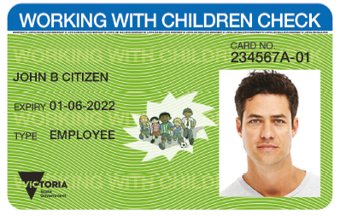
Sample of a Working With Children Check card. This is the information which you need to provide.

Full name  as it appears on the card | Other names  by which this person is known | Position in school | Campus | Working With Children Check |  | Victorian Institute of Teaching
 |  |  |  | Card Number | Card  Expiry Date | Registration Number | Registration Expiry Date
JOHN B CITIZEN | Johnny, Jono | Teacher | Carlton | 234567A-01 | 01-06-2022

Full name  as it appears on the card | Other names  by which this person is known | Position in school | Campus | Working With Children Check |  | Victorian Institute of Teaching
 |  |  |  | Card Number | Card  Expiry Date | Registration Number | Registration Expiry Date

