3

14TH NATIONAL COMMUNITY LANGUAGES
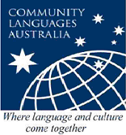
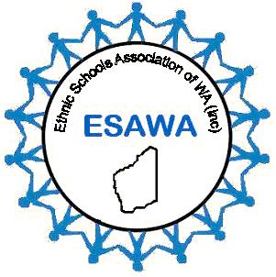
SCHOOLS CONFERENCE

Saturday October 7, 2017
Registration starts 8.30am

50 Ruislip Street, Leederville
Conference Registration

School Name

Language Taught

Address Suburb Code

Phone Mobile

Email Website _____________

Name of Conference Participants:

Name | Special dietary requirements – Vegetarian, Halal

Name of Dinner Participants: Pan Pacific Perth Hotel, 207 Adelaide Terrace, Perth, 7.00pm

Name | Special dietary requirements – Vegetarian, Halal

- Conference Cost per person:
ESAWA Members $35, Non-members $45 includes morning tea and lunch.

- Dinner Cost per person: $95

- Combined conference and dinner cost: ESAWA Members $100, Non-members $110

Please find enclosed cheque for $

Send To:
Fahry Abubaker, abubaker.fahry.f@esav.org.au by September 29, 2017
Cheques made to AFESA National Conference, L2,189 Faraday St Carlton, VIC, 3053

Signed Position Held

